Class4.R

spide

2025-01-16

x<-1:50  
plot(x,sin(x))

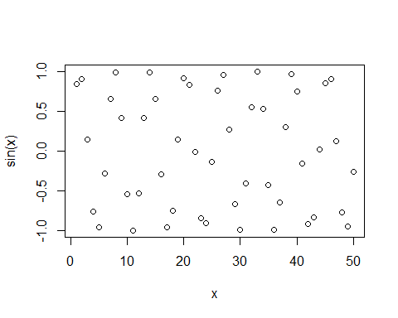

# Make this nicer  
plot(x, sin(x), col="purple", type="l", lwd=3)

